**Course Specialist Test 1 Year 12**

Student name: ________________ Teacher name: ________________

**Task type: Response/Investigation**

**Reading time for this test : 5 mins**

**Working time allowed for this task: 40 mins**

**Number of questions: 7**

**Materials required:** No cals allowed!!

Standard items: Pens (blue/black preferred), pencils (including coloured), sharpener, correction fluid/tape, eraser, ruler, highlighters

Special items: Drawing instruments, templates, NO notes allowed!

**Marks available: 41 marks**

**Task weighting: 13%**

**Formula sheet provided: no, but formulae stated on page 2**

**Note: All part questions worth more than 2 marks require working to obtain full marks.**

**Useful formulae**

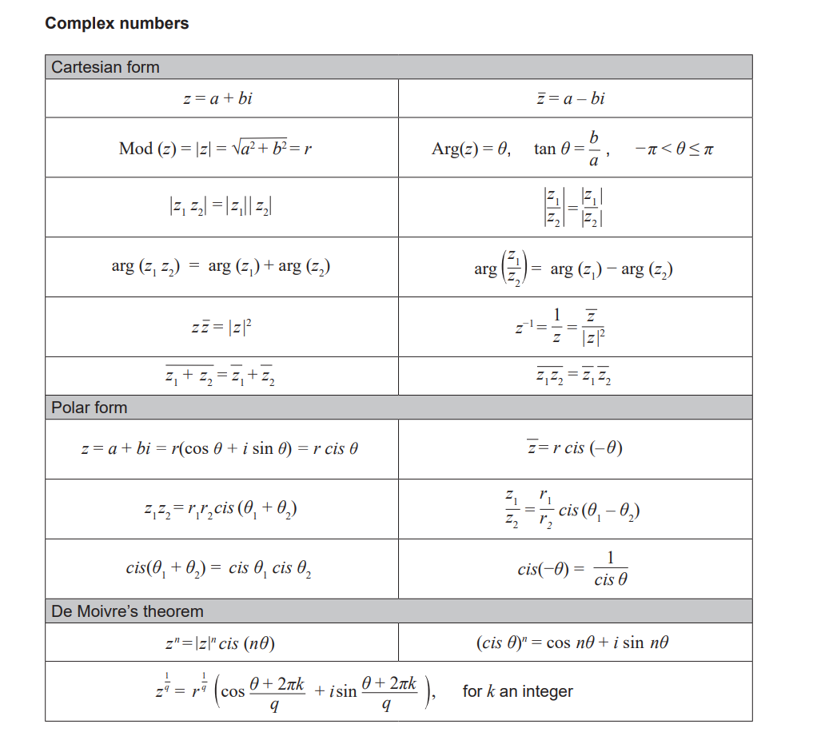





**No cals allowed!!**

Q1 (2, 2, 2 & 2 = 8 marks)

If  and  determine the following:

1. 
2. 
3. 
4. 

Q2 (2 & 3 = 5 marks)

1. Determine the complex roots of  .
2. Use the quadratic equation to prove that if a quadratic equation with real coefficients has any non-real roots then it must have two complex roots and they must be conjugates of each other.

Q3 (4 marks)

Determine all possible real number pairs  such that .

Q4 (2, 2, 2 & 2 = 8 marks)

Consider the complex number .

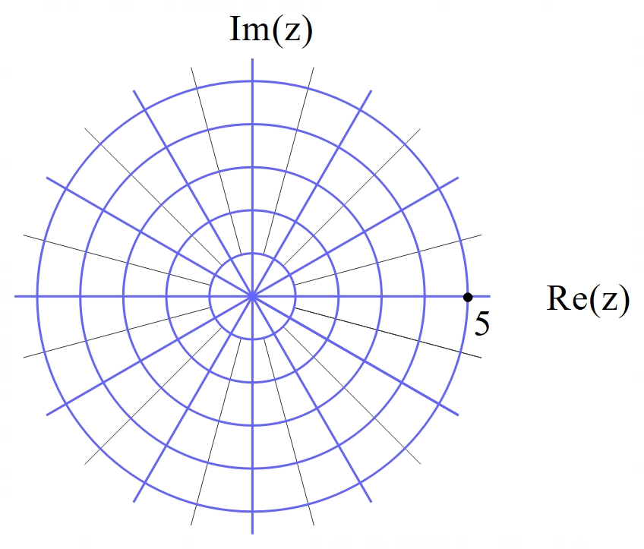

Plot the following on the axes above.

1. 
2. 
3. 
4. 

Q5 (5 marks)

Consider the polynomial  where  are real numbers.

Given that 

and 

Determine the values of .

**(Note: answers without working will receive zero marks)**

Q6 (2, 1, 2 & 2 = 7 marks)

Consider the locus of complex numbers  that satisfy .

1. Sketch the locus on the axes below.

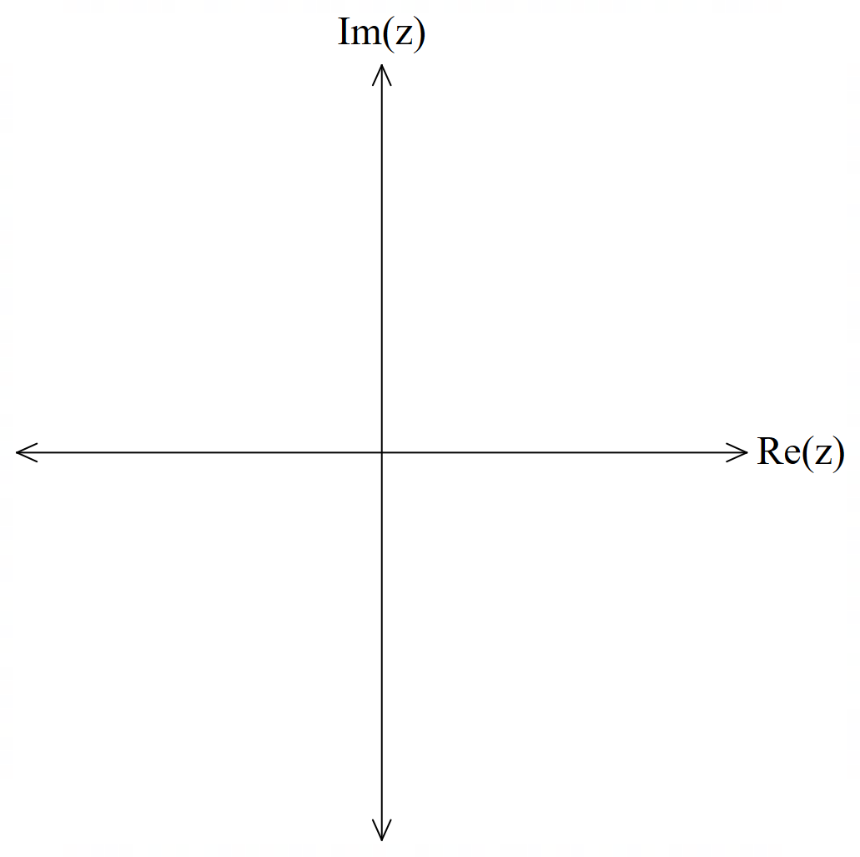

1. State the maximum value of 
2. State the minimum value of  such that .
3. State the maximum value of  such that .

Q7 (4 marks)

Consider the locus defined by  where  are real constants. This locus can also be defined by .

Determine the values of 

**(Note: answers without working will receive zero marks)**

**Working out space**